A000-Eur-Italy-Roman-Bronze bust-Female-200 CE

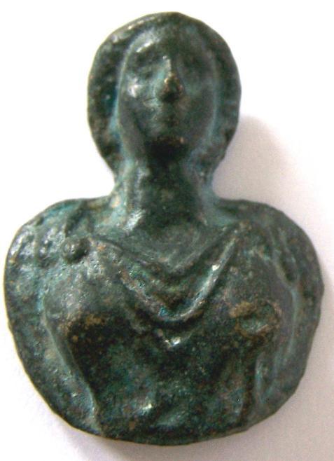

Italy-Roman-Bronze bust-Female

Case no.: 4

Accession Number:

Formal Label: Italy-Roman-Bronze bust-Female

**Display Description:**

**This individual wears a toga and a flower-shaped fibula which was in vogue during the 2nd -3rd centuries CE.**

**Medallions such bronze busts were popular as likenesses of family members and in addition as votive objects which soldiers would take on expeditions to remind them of their loved ones at home.**

**LC Classification: C135**

Date or Time Horizon: ca 200 CE

Geographical Area: Rome

**Map:**

**GPS coordinates:**

Cultural Affiliation: Roman Empire

Medium: bronze

Dimensions: 4 x 3 cm

Weight:

Condition:

Provenance: Old English collection

**Discussion:**

**References:** Baldwiin, Agnes. 1923. *Roman Bronze medallions*. Numismatic notes and monographs, 17.

|  |  |
| --- | --- |
|  | New York : American Numismatic Society |